ALAN HORWITZ

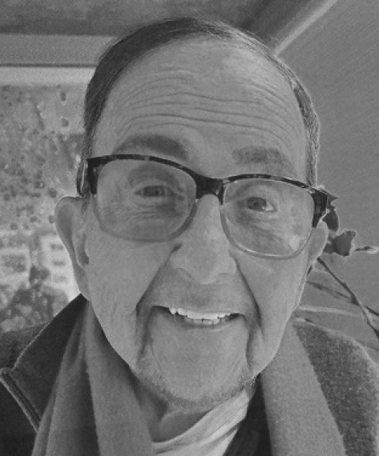
Biographical Brief

Alan Michael Horwitz, a successful Attorney, was born in Chicago and moved to Southern California in 1965. Alan attended De Paul University, where he was active in Business and the Theater. Before Alan went into private practice, he was affiliated with KGO Channel 7/ABC Television in Los Angeles and San Francisco. He was involved in Legal and program matters for over five years and was a Certified Public Accountant before becoming a lawyer.

Alan enjoys a successful career in Business, Television, Movies, and Live Stage Production and is a Counselor and Publisher to many well-known Actors, Musicians, and Vocalists.

Alan was involved for over ten years as a mentor with the Thousand Oak's Alliance of the Arts and Cabrillo Music Theater, which produce live entertainment in the Thousand Oaks and Westlake Village area.

Alan was active in the Iraida Center Foundation for Cancer, The Zoe Christian Center, a homeless shelter in Oxnard, The Lady B Ranch in Apple Valley, a therapeutic horse facility that rehabilitates special needs children, Conejo YMCA, and the Agoura Hills/Oak Park Rotary Club

Presently Alan and his wife Jo Ann are members of the ACT 4 MS, Palm Springs Art Museum, Founders of the Mc Callum Theater in Palm Desert, and maintains his Law Office in the Desert. Alan has been married to Jo Ann Klein Horwitz for 38 years. They moved to Cathedral City eleven years ago from Westlake Village. They have four grown children from previous marriages and eight grandchildren, and an English Golden Retriever named "Lexi". Alan was a former Director of the Montage Board of Directors for two (2) years.

Qualifications and Interest Statement

I am very qualified to be a Director again. My background lends itself to the challenges that occur and are presented to the HOA. I am a Certified Public Accountant (retired), but I am currently an Attorney in the State of California for over forty (40) years and have insight as to those legal matters that present themselves to the homeowners.

Most importantly, I can serve with allegiance to all homeowners and have no favorites, no political or legal affiliations, and I can make independent decisions for all homeowners on a fair and reasonable basis.

My wife and I are full-time residents, and my goal is to continue to keep the "gold" standards of our beautiful community.

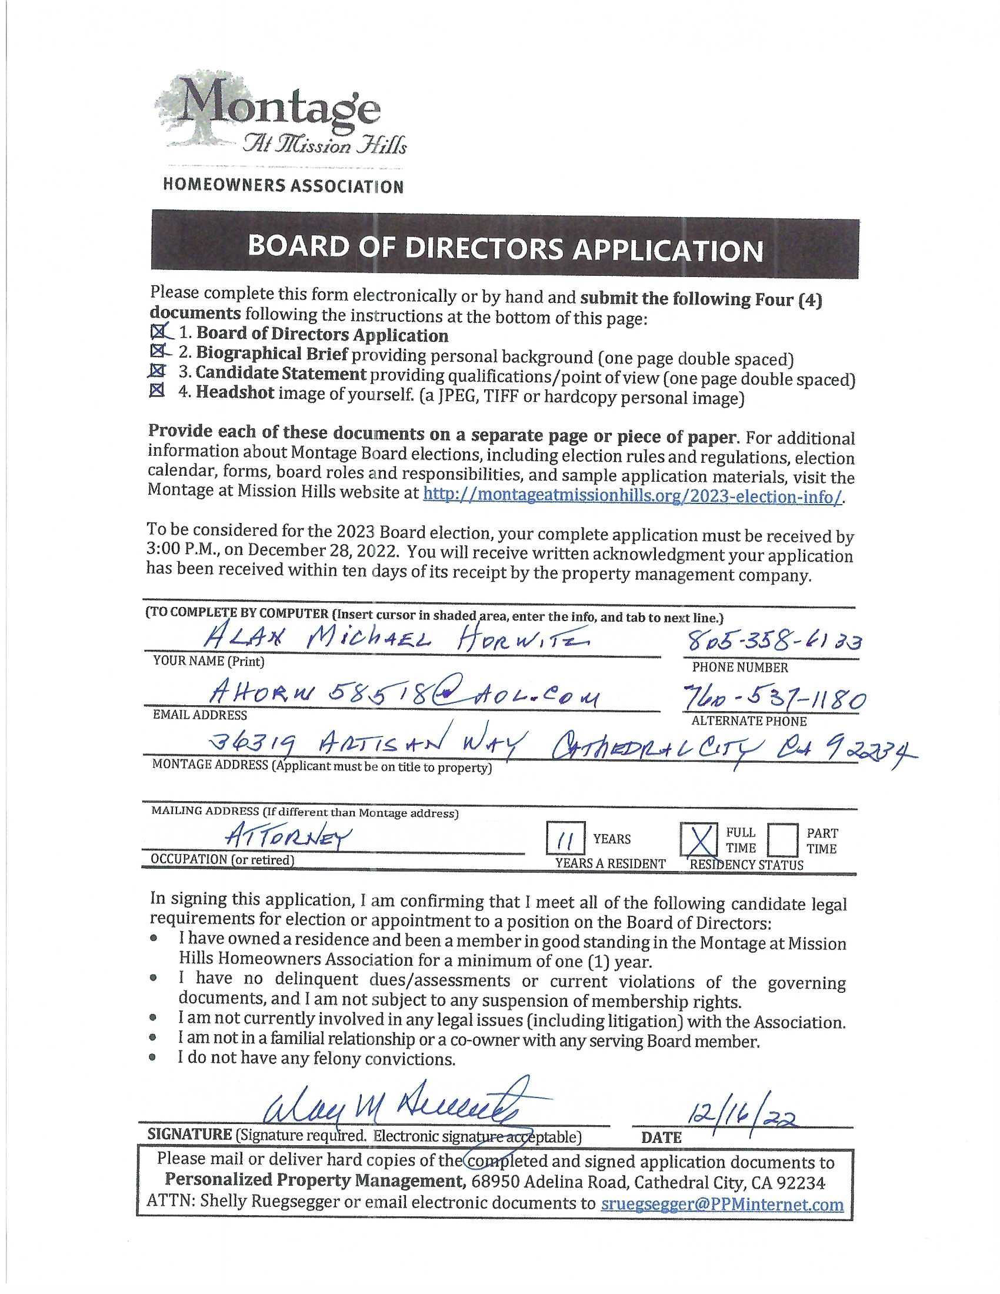

LESLEY (SUE) JOHNSON

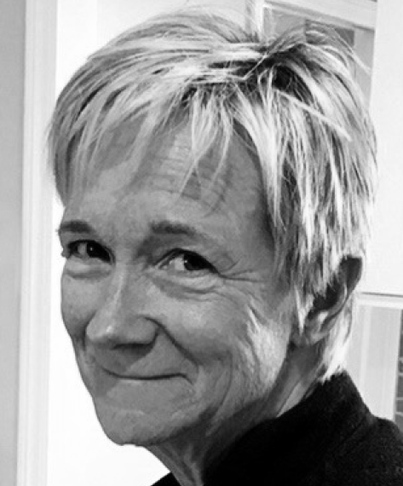
Biographical Brief

My name is Lesley Johnson, more commonly known as Sue. My wife, Andie Gast, and I purchased our house on Dali Drive in April of 2021. Having retired in 2019, we have made this our permanent home. We love the size, beauty, and integrity of Montage and have made many good friends in our short time here.

I grew up in Southern California (Manhattan Beach), attending the University of California, San Diego (B.S. Economics, 1979) and the University of California, Irvine (MBA, 1999). I worked in the Automotive Industry in the area of Information Technology for 40 years while living in Long Beach, California. Although retired, I prefer to remain active, and I hope to provide my experience and perspective to the Montage HOA Board of Directors.

Qualifications and Interest Statement

Although I’ve been a homeowner in Montage at Mission Hills for just under 2 years, I have taken it upon myself to be actively engaged in Montage’s HOA. Within my first year I provided input into the revision of the Rules and Regulations, especially as they pertain to Short Term Rentals. In my second year I’ve been an active member of the Architecture & Landscaping Committee, where I strive to provide a balance of owner’s rights while maintaining a beautiful and cohesive community.

As a Board member, I would like to build upon my initial involvement by providing ongoing property and financial oversight which will benefit all homeowners. In my career I led a department responsible for managing IT systems and services for all back-office functions for Honda across North America, including Accounting, Purchasing, Human Relations, Facilities, and Legal. I believe my broad knowledge base, budgeting experience, and interpersonal and analytical skills could be an asset as a Montage Board Member.

I hope you will give me the opportunity to serve as one of your Montage Board members. Thank you for your consideration.

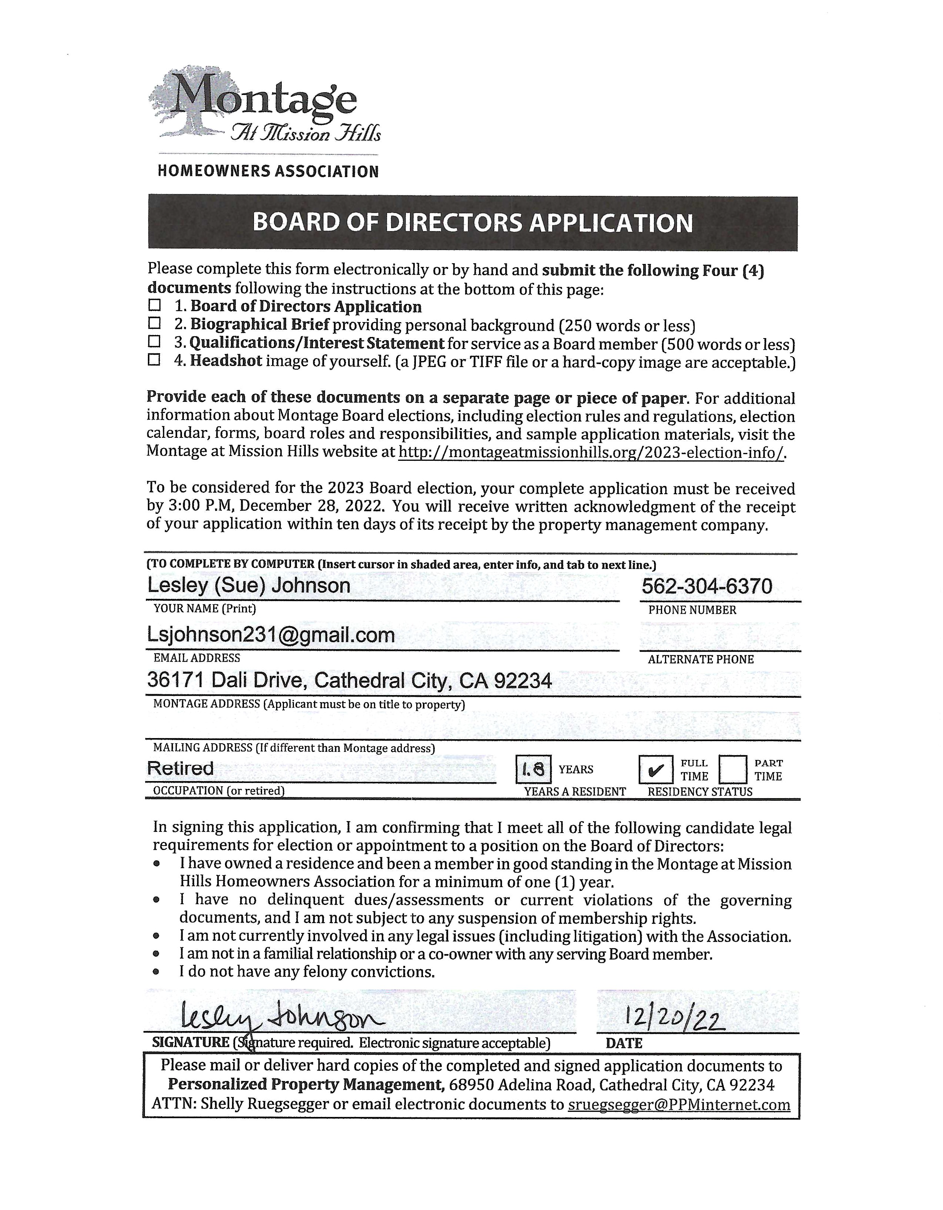

TONY MICHAELIS

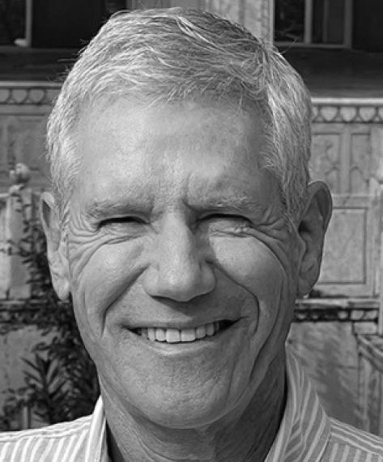
Biographical Brief

My name is Tony Michaelis, and I have lived on Chagall Court since September 2017 with my husband, Frank San Juan, and our dog, Barnaby. We have found Montage to be a great place to live, having made good friends and met many of our neighbors. We also maintain a home in the Silver Lake area of Los Angeles. I am a retired hospital administrator. I spent the majority of my career working at UCLA Medical Center (Director of Operations) & Kaiser Permanente (Strategic Planning and Department Administrator).

I grew up in the Bay Area (Daly City, California), attending the University of San Francisco (B.S. Business, 1977) and San Francisco State University (MBA, Public Finance, 1983). I lived in Washington, D.C., for several years before settling in Los Angeles. Although retired, I plan to remain active in the communities that I live in to improve quality of life. I enjoy playing golf, traveling, working out, and keeping up with current events.

Qualifications and Interest Statement

I initially volunteered as a member of the Architectural Review Committee and became Chair of the Committee in 2018. I was elected to the Board in 2019 and spent my first term learning all aspects of Board responsibilities and activities. I was re-elected to the Board in 2021 and have served as President for the past two years.

As President, I have continued to work with fellow Board members to provide ongoing property and financial oversight and have a good working relationship with Shelly and Nick at PPM. As a member of our Finance Committee, my goal is to efficiently manage our operating expenses and maintain a healthy reserve fund while keeping our monthly assessments as low as possible.

As the Board Liaison to the Architectural Review Committee (ARC), I attend monthly meetings and participate in property inspections. I also work with our homeowner volunteers to make sure we operate well-run and responsive committees. We added tennis benefits to our Mission Hills Country Club membership and had a successful Block Party.

Montage received the Medallion Award for well-run HOAs in 2021 and the 2022 HOA of the Year by the Community Association Institute-Coachella Valley (CAI-CV).

I also think it is important to represent Montage in the Coachella Valley. I am serving on the Homeowner Leadership Committee of CAI-CV and have worked with Cathedral City and Coachella Valley Water District officials on relevant issues, such as short-term vacation rentals and water usage. I am also one of the lead Board members working with our legal team to defend our HOA in the short-term rental lawsuit.

Based on my observations, visitors to our community are consistently providing positive comments on Montage’s appearance, and that is reflected in our higher property values. I believe this is a testament to a well-run HOA, which maintains the principles of our governing documents and rules but uses a balanced and thoughtful approach to implementation.

My approach is to be reasonable, transparent, and lead by consensus. I’ve enjoyed working with volunteer homeowners and all community members to foster an environment that will lead others to provide leadership in the years to come. I hope you will give me the opportunity to continue to serve as one of your Montage Board members.

Thank you for your consideration.

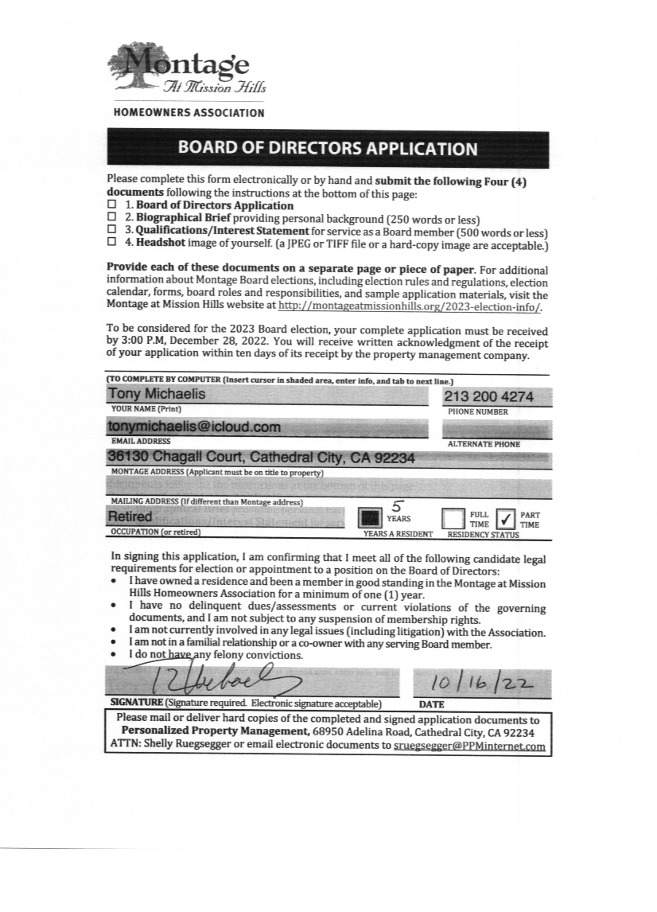
GARY ROMAN

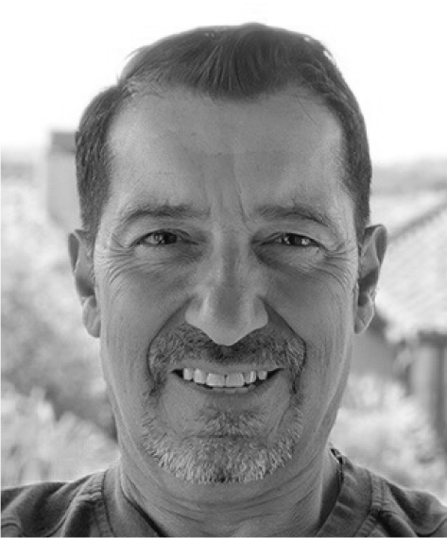
Biographical Brief

“From the desert to the sea, to all of Southern California.” -Jerry Dunphy

I was raised in Southern California, in Los Angeles County, in the Long Beach area, with a second home in Big Bear Lake. I was taught to appreciate a home and to maintain it to the standards of the surrounding area. I was also fortunate to purchase my first home at the age of 27, and I then was more fortunate to obtain a house key in Palm Springs in late 1991.

My partner Frank and I purchased our third home here in the desert, here in Montage, in early 2016. From moving across town from another GHA property, we have gained a wealth of friends, priceless relationships, and a list of social activities that have only bettered our lives.

I am currently winding down my career at the University of California, Irvine, after many years in a staff position that has only been rewarding in all aspects of my life. Before UCI, I was fortunate to get in on the ground floor of L.A. Cellular Telephone Company, where everything I know today I learned in communication.

That all being said; I am looking forward to being in Montage six/seven days a week instead of four.

Qualifications and Interest Statement

My name is Gary Roman, and I have lived in Montage since February 2016. In 2006, we had many friends and acquaintances living here and we knew that one day we would want to end up here. I assumed it was going to be way after retirement, but LIFE itself had a better plan.

Just look at this community as you drive by it, drive into it, live in it. I knew from past Board experience elsewhere, that it took a team to keep up the “Rancho Mirage” standards in Cathedral City. More importantly I knew that one day I would be called to participate on such an adventure, and so I did!

As a candidate for re-election to the Montage at Mission Hills Board, I am running for a seat on the Board of Directors to serve a community that I love to live in.

My past years as a member has been rewarding, mostly learning, and listening to the neighbors of the community and the surrounding communities about Montage and what a place it is to be a part of. I have continued to balance voicing my opinion, avoiding a personal agenda, and keeping in mind what is best for our community. More often, I don't hesitate to venture into unfamiliar territory or go against the grain when necessary. I'm committed, thoughtful and remain open-minded to all ideas and suggestions.

As Member at Large on the Board, I am proud of what we have accomplished over the past five years, and I am deeply committed to helping my colleagues continue our efforts to improve the quality of life at Montage at Mission Hills. I have volunteered and contributed on many of the committees over the years and everything still carries on with the next volunteers in line. Every neighbor should have the opportunity to serve at some level, to have their voices heard and bring in new ideas, and of course enhance their lifestyle.

Since being in Montage all during Covid, I have come to know many more of our homeowners and neighbors and I feel I have been a great asset to a few in need. In this process, I feel a board member needs to care about our neighbors and community. In working with many neighbors who have expressed concerns to me with hopes that their issues will be brought to the next HOA meeting, I have no problem doing that and I honestly feel I still have that authenticated voice.

I am here in the community four to five days a week and I live near the Da Vall gate. With what I put into the HOA, I would consider myself a FULL-TIME resident and will continue to be here for our community. Again, I voluntarily raise my hand for one of the three positions available and look forward to serving you!

Thank you
