(Notice to be sent by mail on letterhead to the addressee or by email)

(Email subject title)
CONFIRMATION OF RECEIPT OF BOARD MEMBER APPLICATION AND DECLARATION OF QUALIFICATION AS A BOARD CANDIDATE
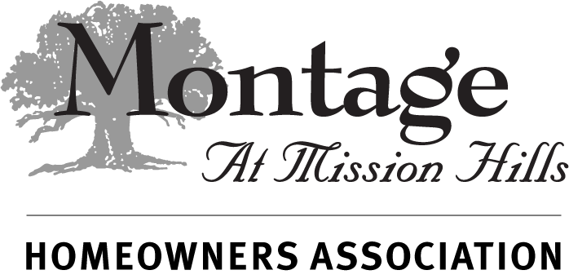
Date (Insert date)

Bill Brown
69703 Van Gogh Road
Cathedral City, CA 92234

Re: Annual Election of Association Board of Directors
Membership Meeting Date: (Insert meeting date)
Approval of Nominee for Candidate to the Board of Directors

Dear Mr. Brown,

Congratulations. This communication is to acknowledge the receipt of your completed Board Member Application and to notify you that your Application has been reviewed and you have been qualified as a candidate for election to the Association Board of Directors at the Annual Membership meeting referenced above. As a result, your name will be submitted to the Board of Directors at its January Regular Board meeting for inclusion as a candidate on the ballot to be distributed to the membership in February.

Should, at the close of the nomination period, the number of qualified candidates be less than or equal to the number of Board positions to be elected this year, the Board will declare the Board election concluded and, by acclamation, appoint all the qualified candidates to Board of Directors to take office at the conclusion of the term of those currently in office.

In the event there are more qualified candidates than positions open, the election process will continue per the procedures set out in the Association governing documents. You can view and download a copy of the Associations Governing documents by Clicking Here or by pasting this address into your browser. http://montageatmissionhills.org/governing-documents/

If you have any further questions regarding your Application, please contact the Inspector of Elections using the contact information below.

Thank you for your interest in serving the Association.

(Insert signature)
John Smith
Inspector of Elections
Montage at Mission Hills Homeowners Association

