Dear Montage Homeowner,
The Board of Directors of Your Montage at Mission Hills Homeowners Association is requesting your ideas for the management and development of the community, and we invite you to apply to join us on the Board of Directors.
Most persons initial response is “No, I don’t have time,” or “I don’t want to get involved in neighborhood politics.” That’s understandable and those are pretty typical responses. Everyone wants to limit the amount of drama in their life. But is also not true.
While on occasion, a resident may wish to address the Board in a face-to-face meeting, a Boardmember never need address a resident one-on-one. In most situations, our management company, Personalized Property Management handles resident issues like dealing with the violations, resident telephone calls and emails both good and bad. They also research all of our bids, enforce the covenants, and process our approved financial responsibilities such as collecting dues and paying bills.
And Montage standing committees (Architectural Review, Welcome, Emergency Preparedness and Website) do much of the other important organizational work. The Montage Board and its four committee chairs have always worked well together through project and administrative matters, which you know is true if you ever attended a bimonthly meeting. And they enjoy each other’s company while doing so.
Don’t think you know enough; you don’t have to be an expert; just someone who cares about the Association. Other veteran board members and the Community Manager help teach and train new members. There also is a significant amount of information and training available through the Community Associations Institute.
Being a Board member requires a few hours of preparation for and participation in six, two to three hour bimonthly meetings. There are also as many as six additional special purpose meetings each year. The Board also conducts an annual Homeowner Membership meeting each year in March. Beyond that each Board member is assigned responsibility as a liaison for one of the standing Committees or other specific responsibilities. The position may involve between 10 and 40 hours per month depending on assignments and one’s personal interests in projects.
What the board requests from you is your review of committee work, interpretation of the Rules and Regulations and CC&R’s, your ideas on community maintenance and improvement and the evaluation of bids, approval of contracts and the development and approval of the annual Reserve Study update and Budget. Most of all we want your input and foresight on the continued success of Montage.
We hope that you will apply to join us on the Board of Directors. This year three of the five Board positions are open this year. We have included a self-nomination form for your use. Simple instructions on how to complete and return the form are included. Your self-nomination form must be submitted by December 30. The election ballots will be sent out in mid-February and must be returned prior to the General Meeting. Results of the election will be announced at the General Meeting on March 20.
Regards,
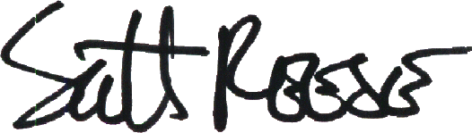
Scott Reese
Inspector of Elections

