BOARD REPORT

June 29, 2021

TO: Montage Board of Directors

FR: Scott Reese, Inspector of Election

RE: 2021 HOA Election Report and Recommendations

Action Requested

- Accept and review report
- Consider a motion to adopt the inspector of elections recommendations as set out in this Annual Report and authorize the association attorney to make any necessary changes to the association’s Election Rules.

Summary

The 2021 Montage board of directors’ election was the first election conducted using the new election rules as adopted by the Board in 2019 in response to changes in State law brought about by the passage of AB 323.

This report and recommendations and the accompanying sample documents have been developed as a guide for the organization in the execution of future homeowner association elections. The calendar - work program and documents should be reviewed annually between July and September prior to the initiation of the election process in October to assure incorporation of any modifications to HOA election law adopted by the Legislature or policy or operational changes instituted by the board and the inspector of elections.

Background

Traditionally, the Montage board of directors annually conducts an election to 1.) select members to serve two-year terms of office on the board of directors; 2.) approve the meeting minutes of the proceeding years Annual general membership meeting, and 3.) consider a proposal that, pursuant to IRS Revenue Ruling, 70-604, any excess operating income over operating expenses for the fiscal year ending be applied against the subsequent tax year. From time to time the election process has also been used to conduct an advisory survey of the membership on important issues or questions for which the Board is seeking an opinion of the membership.

The State Legislature passed sweeping HOA election related legislation in 2019 (AB 323) which was followed by the adoption of new Montage at Mission Hills HOA election policies. The most recent Montage Election Policies can be found on the Governing Documents page of the Association website by Clicking Here or by cutting and pasting this link ( http://montageatmissionhills.org/wp-content/uploads/2020/03/MMH-2020-Election-Rules.pdf ) into an internet browser. In addition, general information including recent election results, the election calendar, Board Candidate Application Forms and video links to recent general membership meetings can always be found on the Election pages of the Association website. This information includes videos and images of Montage HOA election ballots being counted. A link to a videotape of the March 20, 2020 meeting is available by Clicking Here

Recommendations
The inspector of elections is appointed by the board of directors each year to administer the Association’s election process beginning in September and concluding in May with the board’s official certification of results. Following the required vote certification, the Inspector of elections may make recommendations to modify operational processes of the election process as may be necessary to due to changes in State law or as determined to be desirable to improve the Association election policy or processes.

The following recommendations are made by the Inspector of elections for consideration by the Board of directors in advance of the 2022 Board elections:

- Inspector of elections webpage: Consider directing the Inspector of elections, the HOA webmaster and the board president and vice president to create an Informational webpage for the Inspector of elections similar to the webpages established for other board committees. The purpose of the webpage would be to create a location to archive all election processes, forms, instructions and calendars for reference by future IoE’s.

- 2022 Board of Directors Election Calendar: Consider approving the 2022 Montage at Mission Hills Board Election Calendar including identifying March 19, 2022 as the date of the Montage at Mission Hills Board of Directors Election. (Attached).

- Elections by acclamation: Should the 2021 State Legislature adopt AB 502 in the current legislative session, the board should consider directing the HOA attorney to modify the HOA election rules to allow for “elections by acclamation” for uncontested HOA elections where the number of candidates for the board of directors is less than or equal the number of board seats being elected.

- Nominations from the floor: Consider directing the HOA attorney to modify the HOA election rules to eliminate the option of making nominations from the floor at the annual general membership meeting as a means to clarify and simplify the election process.

- Modification of write-in candidate procedures: Consider directing the HOA attorney to modify the HOA election rules to provide that write-in candidates be required to submit their Candidate Forms no later than the beginning of the January board meeting at which the board certifies the slate of candidates for the coming year.

- Election and Ballot Counting Location: Consider annually establishing the then current community managers office location as the official location for Association members to watch all meetings and vote counting unless other provisions are made, or provided by law.

- Annual General Meeting Minutes approval process: In keeping with State law, consider approving a change in operations allowing the board to approve minutes of the Annual general membership meeting at the May or July regular board meeting following the annual general membership meeting rather than delaying the matter for action by the membership at the following years annual general membership meeting.

- Board Inspector of Elections Policy: Consider approving a change in the board polices relative to the appointment of the Inspector of elections to make it consistent with state law by removing wording related to use of the “Management Company” to run the election and count votes and add wording, consistent with State law, that outlines the method of selection the inspector of elections and the duties of that position. (See attached draft)

- Purchase of a HOA Zoom Subscription: Consider authorizing the purchase an Association Zoom Account to solidify a consistent location for all HOA board and committee Meetings.

Next Steps

Authorize the Association attorney to prepare modifications to the current HOA Election Rules to accommodate these recommendations and changes necessary as a result of passage of legislation in the current year

Attachments

- Proposed 2022 Board of Directors Election Calendar
- Draft Board Policy: Inspector of elections.

Current Board Policy

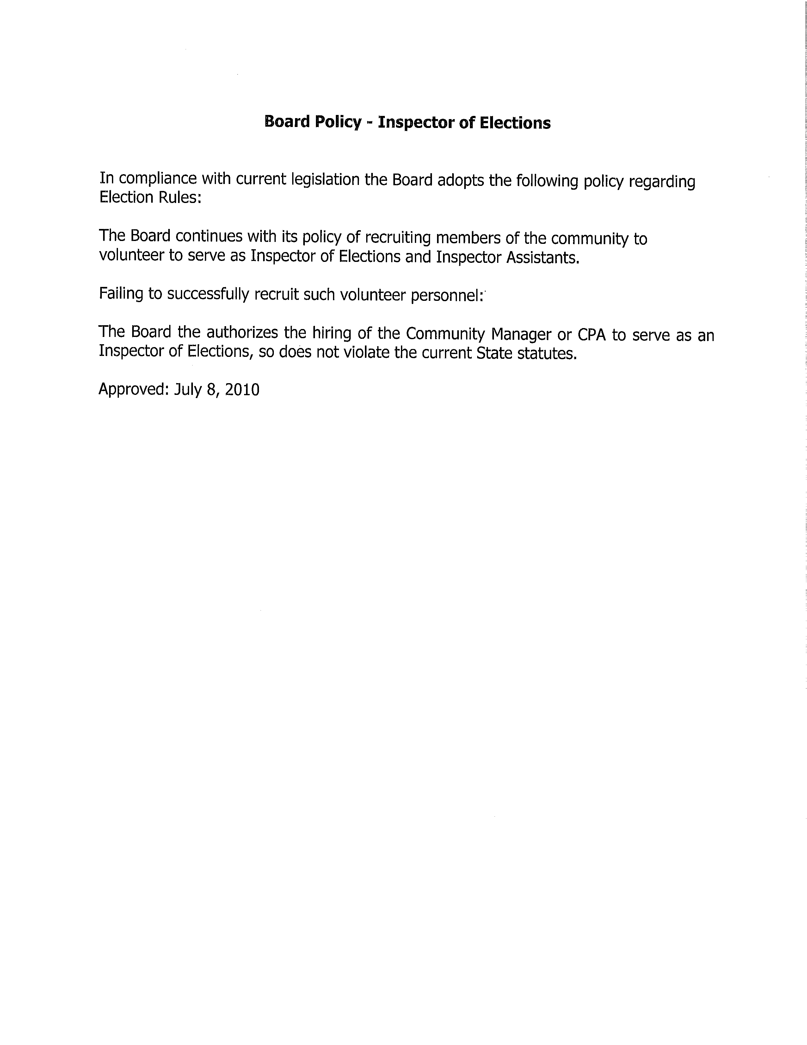

Proposed Draft Board Policy

Board Policy – Inspector of elections

In compliance with current State Law the Board adopts the following policy regarding Election Rules and the annual appointment of an Inspector of elections.

The Board continues with its policy of recruiting members of the association to volunteer to serve as the Inspector of elections appointing an inspector of elections and assistants to the inspector of elections.

Failing to recruit such personnel from the association membership, the Board authorizes the hiring of an independent Inspector of elections in accordance with Civil Code Section 5100, and the association will select an independent third party or parties as an inspector of elections. (Civ. Code § 5110(a).) The number of inspector(s) must either be one (1) or three (3). (Civ. Code § 5110(a).)

Independent Third Party
An independent third party allowed to serve as an association’s inspector of elections includes, but is not limited to, the following: (Civ. Code § 5110(b))
- A volunteer poll worker with the county registrar of voters;
- A licensee of the California Board of Accountancy (CBA);
- A professional or company providing professional inspector of election services who is not a person, business entity, or subdivision of a business entity who is currently employed or under contract to the association for any compensable service other than serving as inspector of elections.
- A notary public; or
- A member of the association, provided that the member is not a director, a candidate for director, or related to a director or to a candidate for director.

Professionals – an independent third party allowed to serve as an association’s inspector of election may not include any “person, business entity, or subdivision of a business entity who is currently employed or under contract to the association for any compensable service other than serving as inspector of elections.” (Civ. Code § 5110(b).)

Prohibited Persons – as previously referenced, the association’s inspector of elections may not include any person who is a member of the board, a candidate for the board, or related to a member of the board or a candidate for the board, nor may it include any person or business entity that is employed or under contract with the association for any service other than serving as inspector of elections. (Civ. Code § 5110(b).)

Selection Methods
The association’s Election Rules specify that the method for selecting independent third parties as inspector(s) of elections must utilize one of the following methods:
- Appointment of the inspector(s) by the board; (Civ. Code § 5105(a)(5)(A))
- Election of the inspector(s) by the members of the association; (Civ. Code § 5105(a)(5)(B)) or
- Any other method for selecting the inspector(s). (Civ. Code § 5105(a)(5)(C).)

Additional Persons Assisting Inspector(s)
The association’s Election Rules also allow the inspector(s) to appoint and oversee additional persons to verify signatures and to count and tabulate votes as the inspector(s) deem appropriate, provided that the persons are also independent third parties in accordance with the above. (Civ. Code § 5105(a)(6).)
Duties of Inspectors
An association’s inspector(s) of elections are required to do all of the necessary tasks required by law, or may designate and supervise the completion of all such responsibilities including the following: (Civ. Code § 5110(c))
- Determine the number of memberships entitled to vote and the voting power of each;
- Determine the authenticity, validity, and effect of proxies, if any;
- Receive ballots;
- Hear and determine all challenges and questions in any way arising out of or in connection with the right to vote;
- Count and tabulate all votes;
- Determine when the polls shall close, consistent with the governing documents;
- Determine the tabulated results of the election;
- Perform any acts as may be proper to conduct the election with fairness to all members in accordance with the required secret balloting procedures, the Corporations Code, and all applicable election rules of the association.
- All of the above must be performed “impartially, in good faith, to the best of the inspector of election’s ability, as expeditiously as practical, and in a manner that protects the interests of all members of the association.” (Civ. Code § 5110(d).)
- Correction of Errors on Candidate List and Voter List
If a member or the association reports an error on the voter list or candidate list to the inspector of elections, the inspector must make the corrections within two (2) business days. (Civ. Code § 5105(a)(7).)

Decisions & Reports
If there are three (3) inspectors of elections, the decision or act of a majority of the inspectors is effective “in all respects” as the decision or act of all the inspectors. (Civ. Code § 5110(d).) Any report made by the inspector(s) is prima facie evidence of the facts stated in the report. (Civ. Code § 5110(d).)

Custody of Ballots, Envelopes, Voter List & Candidate List
The sealed ballots, signed voter envelopes, voter list, and candidate list must at all times be in the custody of the association’s inspector(s) of election or at a location designated by the inspector(s) of elections until after the tabulation of the vote, and until the time allowed by Civil Code Section 5145 for challenging the election has expired (one year). (Civ. Code § 5125; Once that time has expired, the custody of the ballots must be transferred from the inspector(s) of elections to the association. (Civ. Code § 5125.) If there is a recount or other challenge to the election process, the inspector(s) of elections must, upon written request, make the ballots available for inspection and review by any member of the association or the member’s authorized representative. (Civ. Code § 5125; See also “Inspection of Ballots.”)

