Dear Montage Homeowner,
Just a brief note before everyone settles in for the holidays, to one more extend an invitation to you to apply to join us on the Board of Directors.
We promise you that the work is rewarding and the friendships made are enduring beyond your service. There is no better feeling than knowing your neighbors well, receiving their gratitude, and enjoying a sense of accomplishment in service to your community.
We have included a self-nomination form for your use. Simple instructions on how to complete and return the form are included. Your self-nomination form must be submitted by December 30. A Candidate Registration List is available for viewing at PPM should you want to verify if you are eligible to run for office or if you would like to determine if someone you know is eligible. The Board will acknowledge nominations at their January meeting. Election ballots will be sent out in mid-February and must be returned before the General Meeting. Results of the election will be announced at the General Meeting on March 20.
We hope that you will apply to join us on the Board of Directors.
The Montage at Mission Hills Board of Directors wishes you and your family a healthy and happy holiday season and look forward to seeing you around the neighborhood.

Regards,
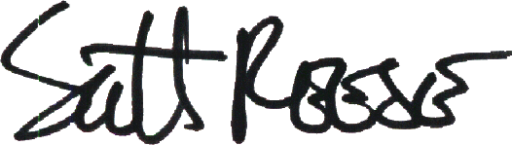
Scott Reese
Inspector of Elections

