TONY MICHAELIS
MONTAGE BOARD NOMINATION STATEMENT 2021

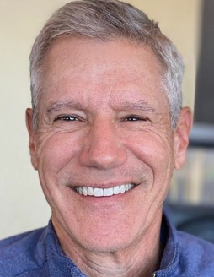
My name is Tony Michaelis and I am seeking your vote for re-election to the Montage Board of Directors. For the past two years it has been my privilege to serve on the Montage Board as Vice President. During my tenure, I have focused on maintaining a well-functioning Architectural Review Committee, financial oversight (Annual Budget and Reserve Study), asset management (contractor oversight & perimeter landscaping) and communications (website and newsletter). I want to ensure that we make the most cost-effective, common sense and pragmatic decisions for our Association.

Over 3 years ago, my husband Frank and I, along with our labradoodle, Barnaby, purchased our Montage home and have enjoyed Desert living ever since.

I was a Healthcare Director and Administrator at UCLA Medical Center and Kaiser Permanente—and now I am retired. I grew up in the Bay Area and attended the University of San Francisco (B.S., Business) and San Francisco State University (MBA, Public Finance). In addition, I recently served as a Budget Advocate for the City of Los Angeles.

I started my involvement with the HOA by volunteering for the Architectural Review Committee and soon thereafter became the Committee Chair. Two years ago, I ran for the Board and was elected a Board Member. During the past 2 years I have taken the time to learn about all aspects of our HOA and how it operates.

The following is a brief summary of the areas I have worked on while a Board member:
- Attended all Board and Committee meetings.

2) Helped lead and maintain a well-functioning Architectural Review Committee (ARC). The ARC is made up of volunteer homeowners who meet monthly to make consensus decisions on Architectural Improvement Requests, complete mandated lighting and home inspections, meet with our landscape contractor and provide input to the Board on relevant issues. In addition, I took the lead in updating our revised paint policy.

3) Served on the Finance Committee and participated in all aspects of our budget and reserve funding process. I created financial spreadsheets projecting likely monthly assessment increases over the next decade as part of our Mission Hills membership renewal review. I have also proactively requested a financial review of our Reserve Study to address concerns by some homeowners regarding our low, fully-funded percentage.

4) Took a fresh look at the work being performed by our contractors through oversight, meetings and a review of existing documentation to make sure we are receiving quality work at a fair price.
My overall goal has been to be an engaged, active Board member who provides a reasonable and objective voice as part of our HOA leadership.

If elected to another Board term, I would like to build upon my involvement by providing ongoing property and financial oversight, along with efforts to enhance communications between the Board and homeowners.

Thank you for your consideration.

