**AD HOC COMMITTEE REPORT**

**August 17, 2020**

**TO: Montage Board of Directors**

**FR: Scott Reese, Rio Del Sol Development Impacts Ad Hoc Committee**

**RE: Rio Del Sol Development Status Report**

1. **Action Requested**
   1. Information Only - Review, Discuss and Accept Report – No further action required.
2. **Current Status**

In June 2018 the Montage Board appointed an Ad Hoc Board Committee to represent the Montage HOA in gathering further information and reporting on matters related to mitigating impacts associated with the proposed completion of construction of the Rio Del Sol (RDS) development by the Rilington Group of La Quinta. RDS is situated immediately west and contiguous with Montage. Scott Reese was appointed the Chair of that committee which includes members most immediately impacted by the proposed Rio Del Sol Development, generally those residents within 200’ notification area of 2018 Rio Del Sol plan amendments.

I have been in contact with the City of Cathedral City Planning Department and Public Works Department every 30 to 60 days since September 2018 to determine the status of the Rilington Group’s permitting process and then reporting back to the Board and/or Ad Hoc Committee any progress reported by City staff.

In my most recent contact (August 2020) with the Robert Rodriquez in the Planning Department he indicates that all plan review and plan check for the construction of models is complete and Rilington only needs to make application and receive approval for building permits in order to move forward. He said this would be a simple process. Rilington has been at this same status since February / March 2020. The Rilington Group website relative to Rio Del Sol has not been updated since fall 2019 and currently indicates phasing as “Entitlements & Product Design Underway: Grading by Q12020.” We are currently in Q3 and it can be said that entitlements are complete and product design was complete in June 2018. No grading has been initiated.

In addition, we continue to monitor Rilington’s other Developments in the valley and see little to no construction or sales activity at Domani, Lido Terra Lago and Villa Portofino in the last 30 days.  The only noticeable work completed appears to be annual weed and erosion control at all sites in July. There is no construction visible at any site. There are only minimal sales staff on duty. The Domani models have been closed and sold.

It is only speculation as to when development might be initiated at Rio Del Sol. The developer has several other developments open and Domani appears to be in the same market segment and is only 30% to 40% complete. Logic would seem to dictate that Rilington would finish other developments before opening another front. The next logical sales window is fall/winter. Models started in September/October could be ready by January 1 with presales started during the construction period. If that were the scenario, it is not likely that there would be construction on Montage contiguous lots for another 9 to 18 months depending on the real estate market. Again, this is all speculation and is subject to many factors.

We will contact the builder when we have confirmation that building permits have been issued for the RDS models. The purpose of that contact will be to arrange a discussion of several issues of concern to Montage related to RDS site grading and drainage, common walls design and construction, site landscaping and selected building massing along the common property line. Our goal will be to attempt to engage the developer in a productive dialogue regarding sensitive site design to minimize construction and post construction occupancy impacts of the new homes.

In the interim, we continue to advise contiguous property owners to be thinking about their common property line and the potential impacts associated with new home construction in order to encourage implementation of possible mitigations on their property in advance of the start of construction in Rio Del Sol. Landscape related mitigations like hedges may take time to grow in order to be effective. Architectural features may take time to design, secure approvals and construction.

I will be providing a copy of this update to the Ad Hoc Committee, new residents on Picasso Court and Dali Lane and to the Architectural Review Committee.

A copy of the 2019 Ad Hoc Committee report on the Rio Del Sol is posted on the montageatmissionhills.org website at this link. <http://montageatmissionhills.org/wp-content/uploads/2020/08/Rio-Del-Sol-Impacts-Presenation-3.pdf>

Please let me know if you have any questions.

1. **Next Steps**
   1. Continue to monitor Rio Del Sol for permitting and construction activity.
   2. Report back to the Montage HOA as needed.
   3. Devise a process to monitor construction impacts and a method of reporting and following up on mitigation issues.
   4. Devise strategies to help Montage homes initiate landscape and architectural improvements to mitigate impacts.
   5. Contact Rilington at the first indication of construction initiation to organize a meeting to discuss construction impact mitigation
   6. Meet with the developer and developer representatives to discuss and secure commitment for implementation of additional mitigation strategies if appropriate.
2. **Chronological Overview Update**
   1. The Rio Del Sol PUD was approved by the City of Cathedral City in 1997.
   2. The development is situated on Indian owned land with a lease that extends to 2071.
   3. The Rilington Group of La Quinta and the of Vancouver, WA are partnering in the development of Rio Del Sol.
   4. PUD’s allow for modification/softening of typical residential lot line, density and architectural design standards in exchange for increased open space and public amenities
   5. To date the project has been developed in phases by at least four different developers/builders. Approximately 200 homes have been developed to date.
   6. There are approximately 220 lots remaining to be developed in the Rio Del Sol Development
   7. The lots are planned in four neighborhoods. The Montecito neighborhood is contiguous to Montage.
   8. The residents of Rio Del Sol supported the completion of the development primarily because:
      1. the undeveloped land is an eyesore;
      2. completion will open southern egress to Sunny Lane and on to DaVall; and
      3. completion of home will bring more stability to the developments financial condition.
   9. The Developer had proposed changes to rear setbacks to move building pads away from the street to allow for installation of 20’ drives in front of garages (initially planned at 2” to 14’) to provide off-street parking for guests. This is necessary because the previously approved 32’ street widths, and incorporated landscape bump-outs unique to the original development proposals result in little or no on-street parking.
   10. On June 6, 2018, the Cathedral City Planning Commission approved modifications to the proposed amendments to the Rio Del Sol PUD (1997) updating architectural design concepts and allowing for a reduction in rear setbacks. In approving the plan, the Commission directed Rilington to modify the proposed rear setback distances of three perimeter lots from the proposed five-foot setback to a seven-foot setback as a concession to requests by members of the Montage HOA.
   11. The July 2018 City Council Approval cleared the way to begin building and infrastructure construction requiring only refinements to engineering to secure building permits. Engineering refinements were submitted in August and building plans were submitted in December.
   12. The newly proposed architecture is consistent and will blend well with Montage Architecture however the architecture style changes the configuration of home layouts moving the active outdoor spaces from the previously approved front yard loaded and middle courtyard loaded active space design, to rear yard active areas.
   13. The quality of Rilington Developments is generally very good and can be seen at such developments as Domini, in Palm Desert, behind the I-10 Auto Mall. [www.domanipalmdesert.com/](https://www.domanipalmdesert.com/)
   14. In August 2018 Rilington had follow-up discussions with City Planning, Building and Engineering Staff relative to the preparation of revised plans and engineering in compliance with the Planning Commissions direction.
   15. In September 2018 Rilington submitted revised engineering drawings and began work with City staff to resolve infrastructure design issues associated with development.
   16. In November /December 2018 Rilington submitted a proposed phasing plan for three neighborhoods (Montecito, Palazzo and Esperanza) and architectural plans for plan check for two neighborhoods, Montecito and Palazzo. The Montecito neighborhood is immediately contiguous to Montage.
   17. The Phasing Plans propose two sets of four models (Montecito and Palazzo Neighborhoods) to be constructed first followed by phased construction of homes as demonstrated in the attached phasing plan.
   18. The developer will first build homes on “infill lots” along Paseo Del Sol in the Montecito Neighborhood where there is existing infrastructure.
   19. The Montecito neighborhood currently has 43 homes in six phases and a Models Phase. There are 13 homes in Phase 3, 4 and 5 (south to north) which are contiguous to the Montage property line and will impact Montage residents.
   20. Plan Check for Montecito and Palazzo models was completed in early 2020 and construction can begin upon applying for and securing building permits. Once building permits are approved, the developer has 180 days to begin construction. Building permits can be extended 90 to 120 upon permission of the City.
   21. Homes take 60 to 90 days to construct. An October 1 construction start date would mean that models could be completed by January or earlier of the following year. The timing of construction of homes adjacent to Montage would depend on the housing market.
   22. In July 2019 The Montage Board appoint an Ad Hoc Board Committee to represent the Montage HOA in gathering further information and reporting on matters related to mitigating impacts associates with Rio Del Sol.
   23. In July 2019 members of the Ad Hock committee met with the Rilington Bruce Maize Vice President of Operations to discuss to open a line of communication and express Montage concerns.
   24. Since them the Ad Hoc Committee Chair has been making periodic resident updates regarding the status of Rio Del Sol plan to Montage Board and residents within the 200’ impact zone.
   25. Currently Rilington is approximately 18 months behind originally projected construction schedule.

Montage Homes Impacted by Rio Del Sol Development

Tertiary Impacts

Visual & Views

Secondary Impacts

Visual, Auditory, Views

Primary Impacts

Visual, Auditory, Privacy, Views Olfactory, Shade & Shadow



Rio Del Sol Montecito Neighborhood Lot Dimensions and Building Pad Locations

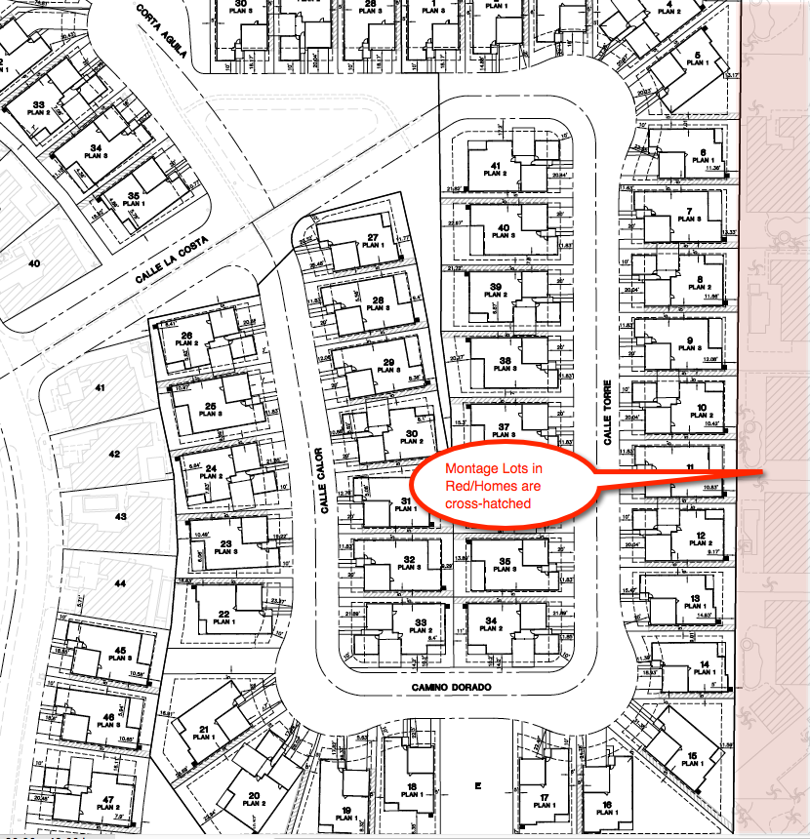

Rilington Phasing Plan for Rio Del Sol Montecito, Palazzo and Esperanza Neighborhoods



Rio Del Sol Neighborhoods. (Montecito Neighborhood in Blue Lots)

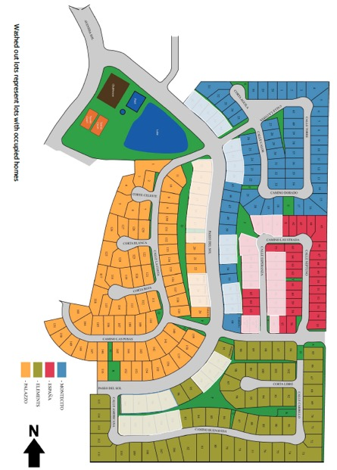

Rilington Rio Del Sol Montecito Neighborhood Plan One Floor Plan

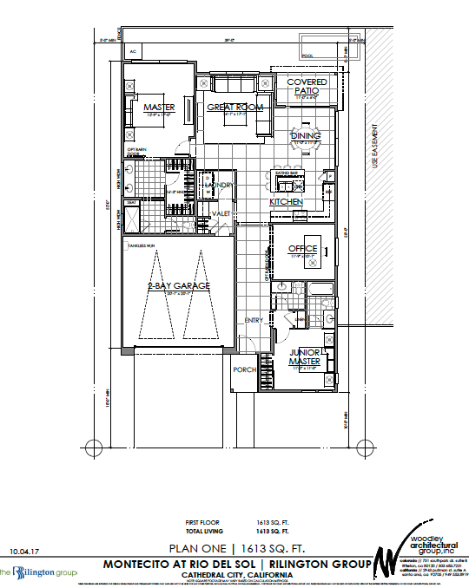

Rilington Rio Del Sol Montecito Neighborhood Plan One Floor Plan

