Swimming Pool Skimmer Basket Sock Liners and Debris Shields
A Good Solution to Those Annoying Palm Tree Droppings and Blowing Bougainvillea Flowers

By Scott Reese

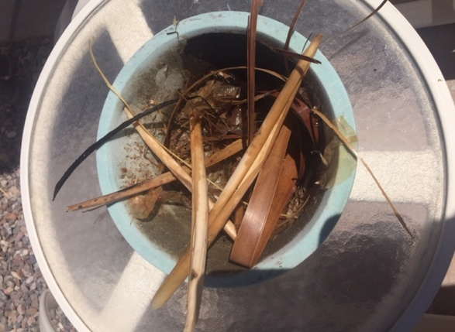
Over the weekend of June 13/14, I spent a lot of time standing in my living room window watching the 25 and 40 mph wind gusts blow debris into my pool. Periodically I would go out with the basket and pole to skim the surface of my pools to remove those brown palm leaf sheaths from the trunks of the Mexican Fan Palms, the dead palm fronds and tiny tan palm flower casings. It was a battle I knew I could not win.
Figure 1 Skimmer basket with sock pulled from skimmer sump. Large debris layer on top.

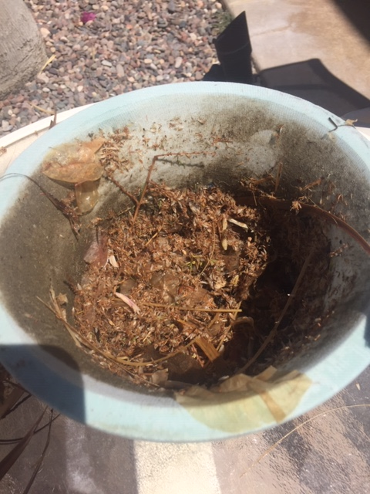
This was a different year however. This year I was prepared. Mid-May I had inserted a fine mesh skimmer basket sock inside my skimmer basket and over the basket edges. And while this didn’t stop the wiry palm frond blades from jamming up HAL, my automated pool cleaning robot, it did capture almost all of the blowing flowers, frond blades, dirt and debris that was floating on the service of my pool.
Figure 3. Skimmer basket with large debris removed. Small debris/palm droppings remain.
Figure 2. Removing loaded skimmer sock from skimmer basket.

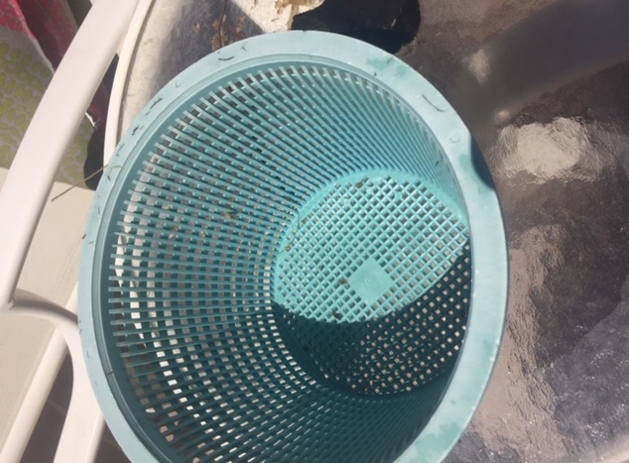
I had remembered reading in a previous year’s Montage newsletters about options for stopping the accumulation of debris (especially small palm flower casings) from jamming the pool pump filter basket and pool filters. The article had suggested use of surface floating pool cleaner devices connected to your pool vacuum which could skim the debris off the top of the pool. The feature also suggested use of a much less expensive skimmer basket fabric inserts to filter debris and dirt. I decided to try the inserts this year. I could not be happier with the results.
Figure 4. Empty skimmer basket showing no debris having penetrated the sock.
Figure 5. New skimmer basket sock put in basket, pulled over rim and ready to be replaced in ground.

I purchased a package of five (see figure 6) at Leslie’s for about $10.00. They are available on line from Amazon in smaller and greater quantities. A package of 30 filter socks for $18.00. Easy to install, you just remove and empty your skimmer basket, pull the elastic sock over and around the rim and then replace the basket. Check the basket routinely and replace the sock as necessary. No need to attempt to remove debris and clean the sock, the socks are so economical to purchase. One large package should easily last a year if you use them judiciously during those periods when you expect the most pool debris loading.
Figure 6. Skimmer basket socks in packages of four.

