MONTAGE AT MISSION HILLS HOMEOWNER’S ASSOCIATION
BOARD OF DIRECTORS REGULAR MEETING
May 8, 2020 MINUTES

A meeting of the Board of Directors of the Montage at Mission Hills Homeowners Association was held on Friday, May 8, 2020 at 9:30am via Zoom video conferencing, Cathedral City, California 92234. A quorum of Board members was present and business was conducted as is outlined herein.

DIRECTORS PRESENT: Curt Beyer, President
Tony Michaelis, Vice President
Tom Tousignant, Treasurer
Norm Giere, Secretary
Gary Roman, Director

ALSO PRESENT:
Shelly Ruegsegger, Senior Community Manager of Personalized Property Management

CALL TO ORDER:
President, Curt Beyer called the meeting to order at 9:31 a.m.

EXECUTIVE SESSION MAY 8, 2020:
- Executive session prior to this meeting; the board discussed discipline, legal and collections.

APPROVAL OF MINUTES:
- The Board reviewed the minutes of the March 13, 2020 executive meeting. Motion to approve the March 13, 2020 regular meeting minutes as presented made by Mr. Tousignant, seconded by Mr. Michaelis, motion carried.

FINANCIAL REPORTS:
- Motion to approve the March 2020 financial report as presented for filing made by Mr. Tousignant, seconded by Mr. Michaelis, motion carried. The full financial reports along with the GL posting reports were emailed to the entire Board prior to the meeting.
- Liens (0)

UNFINISHED BUSINESS:
- Review status of Palm Tree Plan Implementation – Mr. Tousignant explained the HOA is done for the rest of this year. We will get another arborist report later in the year, to see what action we will need to take in 2021.

- Review status of proposed Rio Del Sol Development – Scott Reese – Nothing to report at this time, per Mr. Beyer.

- Review and discussion of progress on Mail Box replacement project (Tabled 03-13) - Mr. Michaelis explained there is currently $10k available in the reserve study for mailbox replacement. The cheapest quote to replace them all is $18k. Not urgent to do now. At this time there are no real complaints from the homeowners. The package box locks are breaking down at this time. Motion made to purchase 3 parcel locks and retain for use down the road when needed, amended to buy 5 made by Mr. Michaelis, seconded by Mr. Tousignant, motion carried.

NEW BUSINESS:
- Approval of proposed Bid Package for Light Inspection and Maintenance Contract - The final bid package with scope, sent out to board members for review. Mr. Tousignant made some recommended changes and asked to send to the bid package to Corona also. All agreed. PPM to send out and have bids for the July meeting.

- Approval of proposed Scope of Work for Perimeter Palm Tree Lighting Contract - Mr. Tousignant sent his comments to Mr. Giere. Tabled.

- Board member assignments discussion – After discussion. The following was approved:
- AVR Committee – Tony Michaelis, Board Liaison, Norm Giere, Chairman
- Welcome Committee – Gary Roman, Board Liaison. Gary, Frank and Norm will meet to decide who will be the Chairman and report back to the board at the next meeting.
- Earthquake Preparedness Committee - Curt Beyer, Board Liaison, Chuck Middleton, Chairman
- Website Committee – Tony Michaelis, Board Liaison
- Agenda Development & Community Communications – Tom Tousignant, Board Liaison

- Appointment of new Architectural Review Committee Chair – See above

- Appointment of Gate Camera Committee – Norm Giere, Board Liaison, Robert Green, Chairman, with Jean-Guy Poitras, Bill Fraser and Joe Ann Horwitz as members and approve draft committee charter. Motion made to approve made by Mr. Tousignant, seconded by Mr. Michaelis, motion carried.

- Appointment of Gate & Entrance Pavement Colors Task Force - Jean-Guy Poitras explained the gates were painted the same color last time. He has done new photo shopped samples. Pavement needs to be a grey color instead of power washing and doing the same color as now. Grey will hide the tire marks and wouldn’t have to be cleaned and resealed as often. Gerald ford gate has some repairs to do before repainting. It was recommended to ask the AVR committee to make recommendations to the committee and board. Table this committee.

- Discussion on retention basin usage (e.g. Dog Park) – Mr. Beyer contacted the city and was told the first thing to think about after declaring a dog park is you have to install handicap access, trash containers that need to be serviced and you have to insure the area. He suggested leave as is. Mr. Michaelis suggested the board continue to look at this item. Tabled.

- Discussion on Reserve Study explanation to homeowners – Mr. Michaelis would like to get some clarification on the reserve account and the board’s funding method. He thinks under 20% funded is a valid concern especially with the future possibility of the asphalt replacement. Mr. Tousignant & Mr. Michaelis jointly develop something for Board consideration at July meeting. Tabled

- Discussion on proposals from Conserve LandCare (TBD) - None

COMMITTEE REPORTS:
- Architectural Review Committee Reports – Meeting Minutes of March 6, 2020 distributed March 8, 2020; Walk thru minutes April 3, 2020 distributed April 6, 2020; Minutes of May 1, 2020 distributed May xx, 2020. Mr. Giere stated they had turned their violation and lighting report into Ms. Oliva of PPM, there were very few violations.
- Emergency Preparedness Committee Reports – Chuck Middleton - None
- Website Committee Report – None
- Welcome Committee Report – None

HOMEOWNERS FORUM:
Jean-Guy Poitras asked about the MHCC social membership. He would like to know if we can cancel the social membership for all the HOA’s members. It would save the HOA money which could be used for other more important expenses like funding the reserves more and planning for operating increases. Mr. Beyer said a survey was done a couple of years ago and there were only 3 homes that did not use the facilities at that time. There is a 10 year agreement that was entered into December 2000 and is renewable for 40 years. Every ten years can renew or cancel. To discontinue this contract, the board would have to get a 67% ballot approval from the member to cancel the contract. Mr. Tousignant and Mr. Michaelis will work on a plan to query the owners. The time line is tight if the board wanted to get this done.

MANAGEMENT REPORTS: Reviewed, no action.

NEXT MEETING: Regular – July 10, 2020 - 9:30 am via Zoom Video Conferencing

ADJOURNMENT: With no further business to be brought before the Board at this time, the meeting was adjourned at 10:39 a.m. on a motion duly made and seconded.

Respectfully submitted,
Shelly Ruegsegger
Senior Community Manager, PPM

APPROVED:

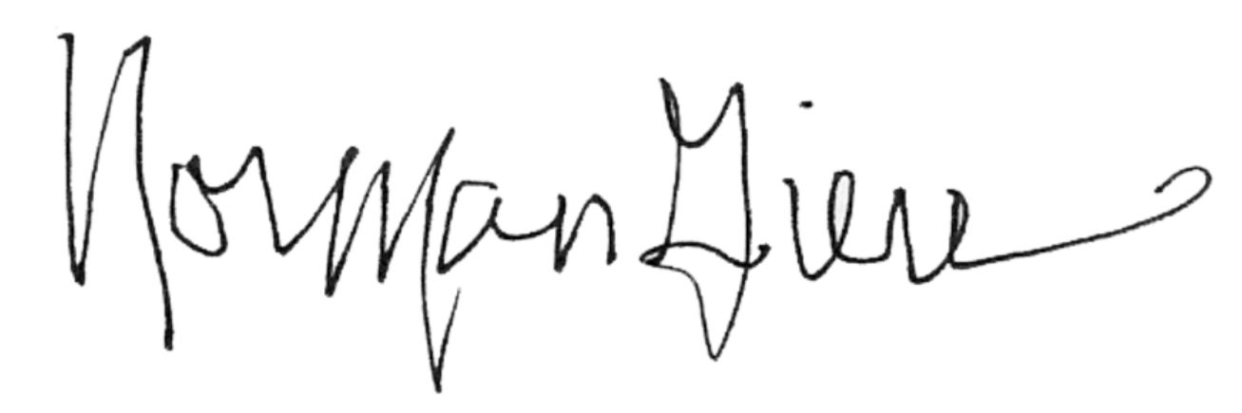 7.10.20
_________________________ _______________
Norm Giere, Secretary Date

